­**Interim Programmatic Report Narrative**

**Instructions:** Save this document on your computer and complete the narrative in the format provided. The final narrative should not exceed five (5) pages. Once complete, upload this document into the on-line interim programmatic report task in Easygrants as instructed.

**1. Summary of Accomplishments**

I conducted 129 hours of surveys for breeding birds in 36 different forest stands across a range of elevations in western Maine and northern New Hampshire. In total, I surveyed 44 different locations, conducting 2-6 surveys at each location. In addition to surveying the bird assemblage at each location, I also characterized the vegetation structure and composition of each stand. Once analyzed, these data will provide important insights into the distribution of Bicknell’s Thrush on actively managed forests and allow a better understanding of the role that forest management can play in promoting conservation of the species.

**2. Project Activities & Outcomes**

**Activities.**

*Objective 1. Conduct surveys for Bicknell’s Thrush in at least 25 stands on commercial forestland in northern New Hampshire and western Maine.*

I spent 129 hours conducting surveys for Bicknell’s Thrush at 44 locations in 36 different forest stands on commercial forestland in northern New Hampshire and western Maine (Fig. 1). Each point was surveyed 2-6 times, with at least 1 0.5-hour survey beginning 30 minutes before sunrise and at least 1 1-hour survey beginning 30 minutes before sunset. Bicknell’s Thrush were present in at least 6 of these stands. I also collected data on structure and composition of the forest in each stand.

*Objective 2. Research conditions that influence the probability that a stand is occupied by Bicknell’s Thrush, including age, management history, elevation, and landscape context*

I am currently analyzing the digital audio recordings collected at each survey location and collecting spatially explicit covariates that describe the management history of each stand as well as key bio-physical characteristics. Once data collection is complete, I will develop occupancy models to estimate the probability that a stand was occupied by Bicknell’s Thrush.

*Objective 3: Use research findings to inform best-management practices for Bicknell’s Thrush in managed forests of New Hampshire and Maine.*

This objective will be addressed following the completion of Objective 2.

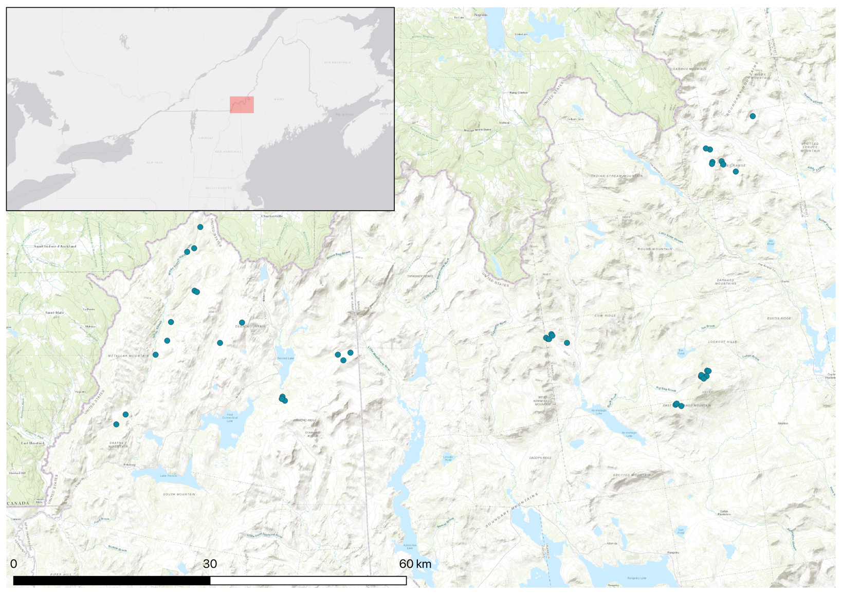

Figure 1. Surveys for Bicknell’s Thrush were conducted in 2017 and 2018 at 44 different locations (blue dots) in 36 different forest stands on lands owned or managed by Weyerhaeuser, LandVest, or Wagner Forest Management. The red shaded area on the inset map in the upper right corner shows the approximate location of the study area.

**Outcomes**

I completed bird surveys in 36 forest stands, and in doing so met Milestone 1 of the project (“Complete standardized surveys for Bicknell’s Thrush in selected stands by June 30, 2018”) and ***exceeded the goal of completing bird surveys in 25 stands***. I am currently analyzing these data and anticipate completing analysis by the end of December, thus meeting Milestone 2 (“Analyze data by December 2018”). Upon meeting this milestone, I will begin building occupancy models that will yield improved estimates of distribution outside of traditional mountaintop habitat and allow a better understanding of the role that forest management can play in promoting conservation of Bicknell’s Thrush. I anticipate meeting Milestone 3 within the proposed timeline (“Disseminate results by April – May 2019”).